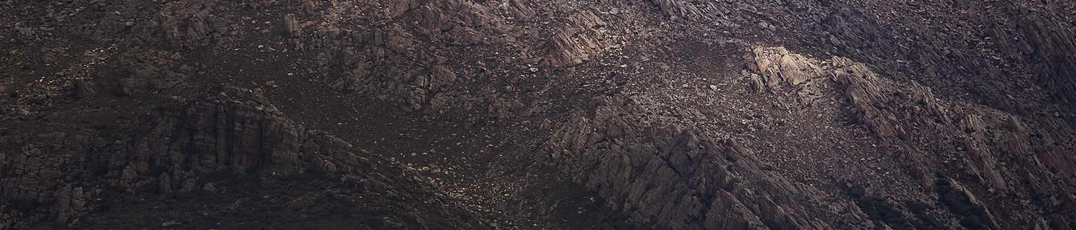
West Coast Artist Commission

Information and Proposal Form for an acquisitive
commission for one West Coast visual artist in 2019

General Information
Background
The Unconformity is a cultural organisation that delivers a range of cultural development and audience outcomes in Queenstown, in Western Tasmania. While our activities are focused upon The Unconformity arts festival (formerly Queenstown Heritage and Arts Festival), a biennial event that will next be held on October 2020, The Unconformity also delivers projects outside of the festival including investing in event equipment for local community use, youth art projects in partnership with Mountain Heights School, artist in residence programs, and support projects for local artists.

Artist Commission Summary
Through the support of Arts Tasmania, in 2019 The Unconformity is offering one $5000 acquisitive commission for a West Coast artist or artist collaboration. The commission is open to 2D art works including painting, works on paper, prints or photography. The commissioned work should have a conceptual connection to the West Coast and be a new and significant work for the artist or artist collaboration.

Exhibition and Legacy
It is intended that the annual commissioned art works will accumulate to build a local collection representing the artists and arts practitioners of the region. The commissions will be installed within public buildings around the region.

Eligibility
Applying artists must live on the West Coast municipality for more than six months of each year. If you would like to apply as a former West Coast resident, you must have lived in the municipality for five or more cumulative years.
The proposed art works will be displayed in public locations therefore must be of a professional standard and able to withstand changes in light, temperature, moisture and humidity. It is the responsibility of the artist to ensure that the materials used will be stable and able to endure over time.
The finished work, including the frame, must be no larger than 1900mm (w) x 1900mm (h), and must be completed and delivered by early October 2019.

Proposal Form Info
The proposal form can be found on page 3 of this document. Proposals need to include:
- A description of who you are
- Your artistic idea and the relationship this has to the West Coast
- What materials, techniques and processes will be used
- The scale of the work and estimated dimensions (if known).

Support Material
In 2019 The Unconformity is taking a new approach towards support material for the West Coast Artist Commission.
We ask that no images of previous work be provided with your submission. Instead, The Unconformity will work with a photographer to professionally document, at an appropriate West Coast venue, five previous works of your choosing. The images will be used as support material for your submission and will be provided to each applicant in high-resolution format for the artist’s future use at their discretion.
If accessing key previous art work may be difficult, if your work is digital or if this process is not appropriate for your art work or your practice, let us know by email so we can discuss alternative options. Transporting art work to and from the documenting venue will be at the artist’s cost.

Deadline
The completed proposal form needs to be submitted by 5:00pm on Monday 15 July 2019, by one of two means:
- Email — Email your completed proposal as an attachment to info@theunconformity.com.au
- Post — Send your printed proposal to The Unconformity, PO Box 235, Queenstown, TAS, 7467.

Assessment
Proposals will be independently assessed by a panel of West Coast people from across the region representing different art forms and cultural experiences, along with industry representatives from the visual art sector.
The proposals will be decided against two criteria:
- The standard, strength of concept and significance of the art work
- The benefit for the artist and the relevance of the work to the West Coast community and the collection.

Commission Agreement and Payment
The successful artist will be required to sign a simple commission agreement. The $5,000 fee is to cover the artist fee, materials and the development and installation of the accepted artwork. The fee will be paid in two instalments—one at the signing of the agreement and the second at the handover and installation stage. Collaborating artists are encouraged to apply however the same $5,000 artist fee applies to the collaborating commission.

Contact
If you have any questions on the proposal form, commission details, eligibility or support material, please contact us by emailing info@theunconformity.com.au.

West Coast Artist Commission
Information and Proposal Form for an acquisitive
commission for one West Coast visual artist in 2019

Proposal Form
This proposal form can be completed typed within the form and submitted via email, or printed and supplied in hard copy.

Name
Address
Phone number
Email address
Do you live on the West Coast?
Who
Provide a short background of who you are and your current art practice.
What
Things to consider are:
- What is your idea for the commission?
- What materials and techniques would be used?
- What are the dimensions of the commissioned work?
- How would a commission impact on you now and into the future?
How
Please let us know:
- Timeframe (start and completion)
- Any specific installation requirements
Other Info
Please provide any other details that are relevant to this proposal.
Submission
Please submit your proposal form by email or by post, by 5:00pm on Monday 15 July 2019:
Email: Send this completed proposal form to info@theunconformity.com.au
Post: Post this completed proposal form to The Unconformity, PO Box 235, Queenstown, Tasmania, 7467.

