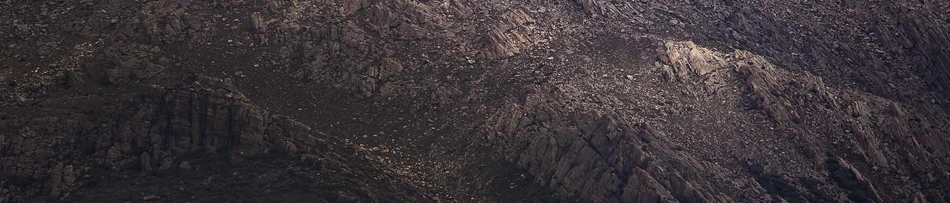
West Coast Artist Commission

Information and Proposal Form for an acquisitive
commission for one West Coast visual artist in 2018.

General Information
Background
The Unconformity Inc. is a cultural organisation that delivers a range of cultural development and audience outcomes in Queenstown, in Western Tasmania. While our activities are focused upon The Unconformity arts festival (formerly Queenstown Heritage and Arts Festival), a biennial event that will next be held on 19-21 October 2018, The Unconformity also develops and delivers projects outside of the festival. In 2018 these include the development of a visitor smartphone app, investing in event equipment for local community use, multiple arts projects in partnership with Mountain Heights School, an artist residency program, development of the Queenie Muster event, and support projects for local artists.

Artist Commission Summary
Through the support of Arts Tasmania, the Unconformity is offering one $5000 acquisitive commission for one West Coast artist in 2018. It is intended that the West Coast Artist Commission is on-going and in 2018 will be open to 2D art works including painting, works on paper, prints or photography. The commissioned work should have a conceptual connection to the West Coast and be a new and significant work for the artist.

Exhibition and Legacy
It is intended that the annual commissioned art works accumulate to build a local collection for the West Coast representing the artists and arts practitioners of the region. The commissions will be installed within public buildings around the region. The inaugural West Coast Artist Commission will be launched during the 2018 Unconformity festival.

Proposal Form Info
The proposal form can be found on page 2 of this document. Proposals need to include:
- Your artistic idea and the relationship this has to the West Coast
- What materials, techniques and processes will be used
- The scale of the work and estimated dimensions (if known).

Deadline
The completed application form and support material needs to be submitted either via email attachment to info@theunconformity.com.au by midnight on Friday 6 July 2018, or posted to The Unconformity, PO Box 315, Queenstown, TAS, 7467 by close of business on Friday 6 July 2018.

Assessment
Proposals will be independently assessed by a panel of four West Coast people from across the region representing different art forms and cultural experiences, along with an industry representative from the visual art sector.
The proposals will be decided against two criteria:
- The standard, strength of concept and significance of the art work
- The benefit for the artist and the relevance of the work to the West Coast community and the collection.
The proposed art works will be displayed in public locations therefore must be of a professional standard and able to withstand changes in light, temperature, moisture and humidity. It is the responsibility of the artist to ensure that the materials used will be stable and able to endure over time.

Commission Agreement and Payment
The successful artist will be required to sign a simple commission agreement. The $5,000 fee is to cover the artist fee, materials and the development and installation of the accepted artwork. The fee will be paid in two instalments – one at the signing of the agreement and the second at the handover and installation stage.

Contact
If you have any questions on the proposal form, commission details or eligibility, please contact us by emailing info@theunconformity.com.au.
West Coast Artist Commission
Information and Proposal Form for an acquisitive
commission for one West Coast visual artist in 2018.

Proposal Form
This proposal form can be completed typed within the form and submitted via email, or printed and supplied in hard copy.

Name
Address
Phone number
Email address
Do you live on the West Coast?
Who
Provide a short background of who you are and your current art practice.
What
Things to consider are:
- What is your idea for the commission?
- What materials and techniques would be used?
- What are the dimensions of the commissioned work?
- How would a commission impact on you now and into the future?
How
Please let us know:
- Timeframe (start and completion)
- Any specific installation requirements
Other Info
Please provide any other details that are relevant to this proposal.
Support Material
Please provide up to 5 total concept drawings or images of similar work.
Submission
Email: Send this completed proposal form and support material to info@theunconformity.com.au by midnight on 6 July 2018.
Post: Please post this completed proposal form and copies of support material to The Unconformity, PO Box 315, Queenstown, Tasmania, 7467, by close of business on 6 July 2018.

